OL Cortina d'Ampezzo 1956

Alpine Skiing
Downhill Men
Pos | Country |  | Athletes | Result
1 |  | Austria | Toni Sailer | 2:52.2
2 |  | Switzerland | Raymond Fellay | 2:55.7
3 |  | Austria | Anderl Molterer | 2:56.2

Downhill Women
Pos | Country |  | Athletes | Result
1 |  | Switzerland | Madeleine Berthod | 1:40.7
2 |  | Switzerland | Frieda Dänzer | 1:45.4
3 |  | Canada | Lucile Wheeler | 1:45.9

Giant Slalom Men
Pos | Country |  | Athletes | Result
1 |  | Austria | Toni Sailer | 3:00.1
2 |  | Austria | Anderl Molterer | 3:06.3
3 |  | Austria | Walter Schuster | 3:07.2

Giant Slalom Women
Pos | Country |  | Athletes | Result
1 |  | Germany | Ossi Reichert | 1:56.5
2 |  | Austria | Putzi Frandl | 1:57.8
3 |  | Austria | Thea Hochleitner | 1:58.2

Slalom Men
Pos | Country |  | Athletes | Result
1 |  | Austria | Toni Sailer | 3:14.7
2 |  | Japan | Chiharu Igaya | 3:18.7
3 |  | Sweden | Stig Sollander | 3:20.2

Slalom Women
Pos | Country |  | Athletes | Result
1 |  | Switzerland | Renée Colliard | 1:52.3
2 |  | Austria | Regina Schöpf | 1:55.4
3 |  | Soviet Union | Yevgeniya Sidorova | 1:56.7

Bobsleigh
2-Man Bobsled
Pos | Country |  | Athletes | Result
1 |  | Italy | Giacomo Conti  Lamberto Dalla Costa | 5:30.14
2 |  | Italy | Renzo Alverà  Eugenio Monti | 5:31.45
3 |  | Switzerland | Max Angst  Harry Warburton | 5:37.46

Four-Man Bobsled
Pos | Country |  | Athletes | Result
1 |  | Switzerland | Robert Alt  Heinrich Angst  Gottfried Diener  Franz Kapus | 5:10.44
2 |  | Italy | Renzo Alverà  Ulrico Girardi  Renato Mocellini  Eugenio Monti | 5:12.10
3 |  | United States | Charles Butler  William Dodge  James Lamy  Arthur Tyler | 5:12.39

Figure Skating
Men
Pos | Country |  | Athletes | Result
1 |  | United States | Hayes Alan Jenkins | 13
2 |  | United States | Ronald Robertson | 16
3 |  | United States | David Jenkins | 27

Pairs
Pos | Country |  | Athletes | Result
1 |  | Austria | Kurt Oppelt  Sissy Schwarz | 14
2 |  | Canada | Norris Bowden  Frances Dafoe | 16
3 |  | Hungary | László Nagy  Marianna Nagy | 32

Women
Pos | Country |  | Athletes | Result
1 |  | United States | Tenley Albright | 12
2 |  | United States | Carol Heiss | 21
3 |  | Austria | Ingrid Wendl | 39

Ice Hockey
Ice Hockey Men
Pos | Country |  | Athletes | Result
1 |  | Soviet Union
2 |  | United States
3 |  | Canada
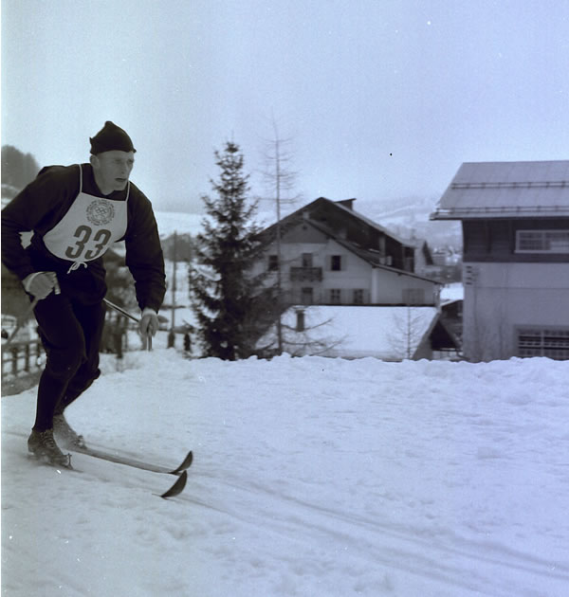
Sverre Stenersen
Nordic Skiing
10km Cross-country Combined Pursuit Women
Pos | Country |  | Athletes | Result
1 |  | Soviet Union | Lyubov Baranova-Kosyreva | 38:11.0
2 |  | Soviet Union | Radya Yeroshina | 38:16.0
3 |  | Sweden | Sonja Ruthström-Edström | 38:23.0

20km Cross-country Combined Pursuit Men
Pos | Country |  | Athletes | Result
1 |  | Norway | Hallgeir Brenden | 49:39.0
2 |  | Sweden | Sixten Jernberg | 50:14.0
3 |  | Soviet Union | Pavel Kolchin | 50:17.0

30km Cross-country Freestyle Men
Pos | Country |  | Athletes | Result
1 |  | Finland | Veikko Hakulinen | 1:44:06
2 |  | Sweden | Sixten Jernberg | 1:44:30
3 |  | Soviet Union | Pavel Kolchin | 1:45:45

4x10km Cross-country Relay Men
Pos | Country |  | Athletes | Result
1 |  | Soviet Union | Nikolay Anikin  Pavel Kolchin  Vladimir Kuzin  Fyodor Terentyev | 2:15:30
2 |  | Finland | Veikko Hakulinen  August Kiuru  Jormo Kortelainen  Arvo Viitanen | 2:16:31
3 |  | Sweden | Sixten Jernberg  Lennart Larsson  Per-Erik Larsson  Gunnar Samuelsson | 2:17:42

4x5km Cross-country Relay Women
Pos | Country |  | Athletes | Result
1 |  | Finland | Mirja Hietamies  Sirkka Polkunen  Siiri Rantanen | 1:09:01
2 |  | Soviet Union | Lyubov Baranova-Kosyreva  Alevtina Kolchina  Radya Yeroshina | 1:09:28
3 |  | Sweden | Anna-Lisa Eriksson  Irma Johansson  Sonja Ruthström-Edström | 1:09:48

50km Cross-country Freestyle Men
Pos | Country |  | Athletes | Result
1 |  | Sweden | Sixten Jernberg | 2:50:27
2 |  | Finland | Veikko Hakulinen | 2:51:45
3 |  | Soviet Union | Fyodor Terentyev | 2:53:32

Nordic Combined, Individual
Pos | Country |  | Athletes | Result
1 |  | Norway | Sverre Stenersen | 455.0
2 |  | Sweden | Bengt Eriksson | 437.4
3 |  | Poland | Franciszek Gasienica-Gron | 436.8

Ski Jump 120m
Pos | Country |  | Athletes | Result
1 |  | Finland | Antti Hyvärinen | 227.0
2 |  | Finland | Aulis Källakorpi | 225.0
3 |  | Germany | Harry Glass | 224.5

Speed Skating
10000m Men
Pos | Country |  | Athletes | Result
1 |  | Sweden | Sigge Ericsson | 16:35.9
2 |  | Norway | Knut Johannesen | 16:36.9
3 |  | Soviet Union | Oleg Goncharenko | 16:42.3

1500m Men
Pos | Country |  | Athletes | Result
1 |  | Soviet Union | Yevgeny Grishin  Yury Mikhaylov | 2:08.6
3 |  | Finland | Toivo Salonen | 2:09.4

5000m Men
Pos | Country |  | Athletes | Result
1 |  | Soviet Union | Boris Shilkov | 7:48.7
2 |  | Sweden | Sigge Ericsson | 7:56.7
3 |  | Soviet Union | Oleg Goncharenko | 7:57.5

500m Men
Pos | Country |  | Athletes | Result
1 |  | Soviet Union | Yevgeny Grishin | 40.2
2 |  | Soviet Union | Rafael Grach | 40.8
3 |  | Norway | Alv Gjestvang | 41.0

