OL Oslo 1952

Alpine grener
Downhill Men
Pos | Country |  | Athletes | Result
1 |  | Italy | Zeno Colò | 2:30.8
2 |  | Austria | Othmar Schneider | 2:32.0
3 |  | Austria | Christian Pravda | 2:32.4

Downhill Women
Pos | Country |  | Athletes | Result
1 |  | Austria | Trude Jochum-Beiser | 1:47.1
2 |  | Germany | Mirl Buchner | 1:48.0
3 |  | Italy | Giuliana Chenal-Minuzzo | 1:49.0

Giant Slalom Men
Pos | Country |  | Athletes | Result
1 |  | Norway | Stein Eriksen | 2:25.0
2 |  | Austria | Christian Pravda | 2:26.9
3 |  | Austria | Toni Spiss | 2:28.8

Giant Slalom Women
Pos | Country |  | Athletes | Result
1 |  | United States | Andrea Mead-Lawrence | 2:06.8
2 |  | Austria | Dagmar Rom | 2:09.0
3 |  | Germany | Mirl Buchner | 2:10.0

Slalom Men
Pos | Country |  | Athletes | Result
1 |  | Austria | Othmar Schneider | 2:00.0
2 |  | Norway | Stein Eriksen | 2:01.2
3 |  | Norway | Guttform Berge | 2:01.7

Slalom Women
Pos | Country |  | Athletes | Result
1 |  | United States | Andrea Mead-Lawrence | 2:10.6
2 |  | Germany | Ossi Reichert | 2:11.4
3 |  | Germany | Mirl Buchner | 2:13.3

Bobsleigh
2-Man Bobsled
Pos | Country |  | Athletes | Result
1 |  | Germany | Lorenz Nieberl  Andreas Ostler | 5:24.54
2 |  | United States | Stanley Benham  Pat Martin | 5:26.89
3 |  | Switzerland | Fritz Feierabend  Stephan Waser | 5:27.71

Four-Man Bobsled
Pos | Country |  | Athletes | Result
1 |  | Germany | Franz Kemser  Friedrich Kuhn  Lorenz Nieberl  Andreas Ostler | 5:07.84
2 |  | United States | James Atkinson  Stanley Benham  Howard Crossett  Pat Martin | 5:10.48
3 |  | Switzerland | Fritz Feierabend  André Filippini  Albert Madörin  Stephan Waser | 5:11.70

Kunstløp
Men
Pos | Country |  | Athletes | Result
1 |  | United States | Richard Button | 9
2 |  | Austria | Helmut Seibt | 23
3 |  | United States | James Grogan | 24

Pairs
Pos | Country |  | Athletes | Result
1 |  | Germany | Paul Falk  Ria Falk | 11.5
2 |  | United States | Karol Kennedy  Peter Kennedy | 17.5
3 |  | Hungary | László Nagy  Marianna Nagy | 31

Women
Pos | Country |  | Athletes | Result
1 |  | United Kingdom | Jeannette Altwegg | 14
2 |  | United States | Tenley Albright | 22
3 |  | France | Jacqueline du Bief | 24

Ishockey
Ice Hockey Men
Pos | Country |  | Athletes | Result
1 |  | Canada
2 |  | United States
3 |  | Sweden

Ski nordiske grener
10km Cross-country Combined Pursuit Women
Pos | Country |  | Athletes | Result
1 |  | Finland | Lydia Wideman | 41:40.0
2 |  | Finland | Mirja Hietamies | 42:39.0
3 |  | Finland | Siiri Rantanen | 42:50.0

20km Cross-country Combined Pursuit Men
Pos | Country |  | Athletes | Result
1 |  | Norway | Hallgeir Brenden | 1:01:34.0
2 |  | Finland | Tapio Mäkelä | 1:02:09.0
3 |  | Finland | Paavo Lonkila | 1:02:20.0

4x10km Cross-country Relay Men
Pos | Country |  | Athletes | Result
1 |  | Finland | Heikki Hasu  Urpo Korhonen  Paavo Lonkila  Tapio Mäkelä | 2:20:16
2 |  | Norway | Hallgeir Brenden  Magnar Estenstad  Mikal Kirkholt  Martin Stokken | 2:23:13
3 |  | Sweden | Sigurd Andersson  Enar Josefsson  Martin Lundström  Nils Tåpp | 2:24:13

50km Cross-country Freestyle Men
Pos | Country |  | Athletes | Result
1 |  | Finland | Veikko Hakulinen | 3:33:33
2 |  | Finland | Eero Kolehmainen | 3:38:11
3 |  | Norway | Magnar Estenstad | 3:38:28

Nordic Combined, Individual
Pos | Country |  | Athletes | Result
1 |  | Norway | Simon Slåttvik | 451.621
2 |  | Finland | Heikki Hasu | 447.500
3 |  | Norway | Sverre Stenersen | 436.335

Ski Jump 120m
Pos | Country |  | Athletes | Result
1 |  | Norway | Arnfinn Bergmann | 226.0
2 |  | Norway | Torbjørn Falkanger | 221.5
3 |  | Sweden | Karl Holmström | 219.5
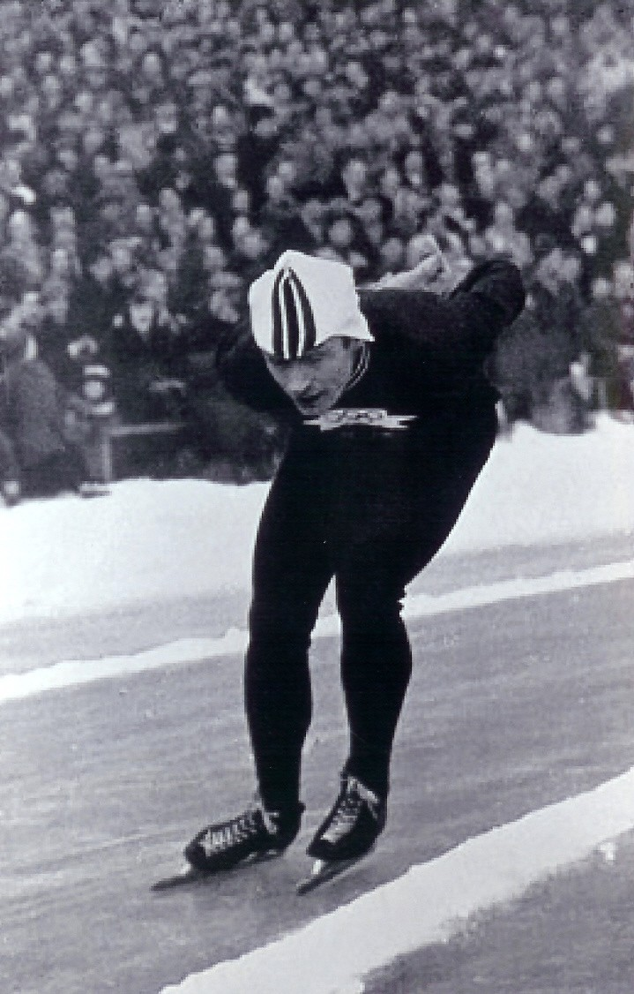
”Hjallis”

Skøyter
10000m Men
Pos | Country |  | Athletes | Result
1 |  | Norway | Hjallis Andersen | 16:45.8
2 |  | Netherlands | Kees Broekman | 17:10.6
3 |  | Sweden | Carl-Erik Asplund | 17:16.6

1500m Men
Pos | Country |  | Athletes | Result
1 |  | Norway | Hjallis Andersen | 2:20.4
2 |  | Netherlands | Wim van der Voort | 2:20.6
3 |  | Norway | Roald Aas | 2:21.6

5000m Men
Pos | Country |  | Athletes | Result
1 |  | Norway | Hjallis Andersen | 8:10.6
2 |  | Netherlands | Kees Broekman | 8:21.6
3 |  | Norway | Sverre Haugli | 8:22.4

500m Men
Pos | Country |  | Athletes | Result
1 |  | United States | Ken Henry | 43.2
2 |  | United States | Donald McDermott | 43.9
3 |  | Norway | Arne Johansen | 44.0
3 |  | Canada | Gordon Audley | 44.0

