Lake Placid 1932

Bobsleigh
2-Man Bobsled
Pos | Country |  | Athletes | Result
1 |  | United States | Curtis Stevens  Hubert Stevens | 8:14.74
2 |  | Switzerland | Reto Capadrutt  Oscar Geier | 8:16.28
3 |  | United States | John Heaton  Robert Minton | 8:29.15

Four-Man Bobsled
Pos | Country |  | Athletes | Result
1 |  | United States | Eddie Eagan  Billy Fiske  Clifford Grey  Jay O'Brien | 7:53.68
2 |  | United States | Percy Bryant  Henry Homburger  Edmund Horton  Paul Stevens | 7:55.70
3 |  | Germany | Sebastian Huber  Hanns Kilian  Max Ludwig  Hans Mehlhorn | 8:00.04

Figure Skating
Men
Pos | Country |  | Athletes | Result
1 |  | Austria | Karl Schäfer | 9
2 |  | Sweden | Gillis Gråfström | 13
3 |  | Canada | Montgomery Wilson | 24

Pairs
Pos | Country |  | Athletes | Result
1 |  | France | Pierre Brunet  Andrée Brunet-Joly | 12
2 |  | United States | Sherwin Badger  Beatrix Loughran | 16
3 |  | Hungary | Emília Rotter  László Szollàs | 20

Women
Pos | Country |  | Athletes | Result
1 |  | Norway | Sonja Henie | 7
2 |  | Austria | Fritzi Burger | 18
3 |  | United States | Maribel Vinson | 23

Ice Hockey
Ice Hockey Men
Pos | Country |  | Athletes | Result
1 |  | Canada
2 |  | United States
3 |  | Germany

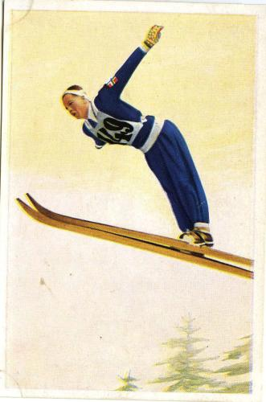
Birger Ruud
Nordic Skiing
20km Cross-country Combined Pursuit Men
Pos | Country |  | Athletes | Result
1 |  | Sweden | Sven Utterström | 1:23:07.0
2 |  | Sweden | Axel Wikström | 1:25:07.0
3 |  | Finland | Veli Saarinen | 1:25:24.0

50km Cross-country Freestyle Men
Pos | Country |  | Athletes | Result
1 |  | Finland | Veli Saarinen | 4:28:00
2 |  | Finland | Väinö Liikkanen | 4:28:20
3 |  | Norway | Arne Rustadstuen | 4:31:53

Nordic Combined, Individual
Pos | Country |  | Athletes | Result
1 |  | Norway | Johan Grøttumsbråten | 446.00
2 |  | Norway | Ole Stenen | 436.05
3 |  | Norway | Hans Vinjarengen | 434.60

Ski Jump 120m
Pos | Country |  | Athletes | Result
1 |  | Norway | Birger Ruud | 228.1
2 |  | Norway | Hans Beck | 227.0
3 |  | Norway | Kåre Walberg | 219.5

Speed Skating
10000m Men
Pos | Country |  | Athletes | Result
1 |  | United States | Irving Jaffee | 19:13.6
2 |  | Norway | Ivar Ballangrud
3 |  | Canada | Frank Stack

1500m Men
Pos | Country |  | Athletes | Result
1 |  | United States | Jack Shea | 2:57.5
2 |  | Canada | Alexander Hurd
3 |  | Canada | William Logan

5000m Men
Pos | Country |  | Athletes | Result
1 |  | United States | Irving Jaffee | 9:40.8
2 |  | United States | Edward Murphy
3 |  | Canada | William Logan

500m Men
Pos | Country |  | Athletes | Result
1 |  | United States | Jack Shea | 43.4
2 |  | Norway | Bæla Evensen
3 |  | Canada | Alexander Hurd

