OL St. Moritz 1928

Bobsleigh
Four-Man Bobsled
Pos | Country |  | Athletes | Result
1 |  | United States | Billy Fiske  Clifford Grey  Geoffrey Mason  Richard Parke  Nion Tucker | 3:20.5
2 |  | United States | Thomas Doe  David Granger  Jennison Heaton  Lyman Hine  Jay O'Brien | 3:21.0
3 |  | Germany | Hans Hess  Sebastian Huber  Hanns Kilian  Valentin Krempl  Hans Nägle | 3:21.9

Figure Skating
Men
Pos | Country |  | Athletes | Result
1 |  | Sweden | Gillis Gråfström | 12
2 |  | Austria | Willy Böckl | 13
3 |  | Belgium | Robert van Zeebroeck | 27

Pairs
Pos | Country |  | Athletes | Result
1 |  | France | Pierre Brunet  Andrée Brunet-Joly | 14
2 |  | Austria | Otto Kaiser  Lilly Scholz | 17
3 |  | Austria | Melitta Brunner  Ludwig Wrede | 29

Women
Pos | Country |  | Athletes | Result
1 |  | Norway | Sonja Henie | 8
2 |  | Austria | Fritzi Burger | 25
3 |  | United States | Beatrix Loughran | 28

Ice Hockey
Ice Hockey Men
Pos | Country |  | Athletes | Result
1 |  | Canada
2 |  | Sweden
3 |  | Switzerland

Lugeing
Skeleton Men
Pos | Country |  | Athletes | Result
1 |  | United States | Jennison Heaton | 3:01.8
2 |  | United States | John Heaton | 3:02.8
3 |  | United Kingdom | David Northesk | 3:05.1

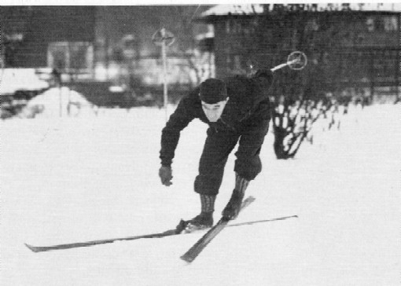
Johan Grøttumsbråten
Nordic Skiing
20km Cross-country Combined Pursuit Men
Pos | Country |  | Athletes | Result
1 |  | Norway | Johan Grøttumsbråten | 1:37:01.0
2 |  | Norway | Ole Hegge | 1:39:01.0
3 |  | Norway | Reidar Ødegaard | 1:40:11.0

50km Cross-country Freestyle Men
Pos | Country |  | Athletes | Result
1 |  | Sweden | Per Erik Hedlund | 4:52:03
2 |  | Sweden | Gustaf Jonsson | 5:05:30
3 |  | Sweden | Volger Andersson | 5:05:46

Nordic Combined, Individual
Pos | Country |  | Athletes | Result
1 |  | Norway | Johan Grøttumsbråten | 17.833
2 |  | Norway | Hans Vinjarengen | 15.303
3 |  | Norway | John Snersrud | 15.021

Ski Jump 120m
Pos | Country |  | Athletes | Result
1 |  | Norway | Alf Andersen | 19.208
2 |  | Norway | Sigmund Ruud | 18.542
3 |  | Czechoslovakia | Rudolf Burkert | 17.937

Speed Skating
1500m Men
Pos | Country |  | Athletes | Result
1 |  | Finland | Clas Thunberg | 2:21.1
2 |  | Norway | Bæla Evensen | 2:21.9
3 |  | Norway | Ivar Ballangrud | 2:22.6

5000m Men
Pos | Country |  | Athletes | Result
1 |  | Norway | Ivar Ballangrud | 8:50.5
2 |  | Finland | Julius Skutnabb | 8:59.1
3 |  | Norway | Bæla Evensen | 9:01.1

500m Men
Pos | Country |  | Athletes | Result
1 |  | Norway | Bæla Evensen | 43.4
1 |  | Finland | Clas Thunberg | 43.4

