OL Chamonix 1924
Bobsleigh
Four-Man Bobsled
Pos | Country |  | Athletes | Result
1 |  | Switzerland | Alfred Neveu  Eduard Scherrer  Alfred Schläppi  Heinrich Schläppi | 5:45.54
2 |  | United Kingdom | Thomas Arnold  Ralph Broome  Alexander Richardson  Rodney Soher | 5:48.83
3 |  | Belgium | René Mortiaux  Charles Mulder  Paul van den Broeck  Victor Verschueren  Henri Willems | 6:02.29

Kunstløp/Figure Skating
Men
Pos | Country |  | Athletes | Result
1 |  | Sweden | Gillis Gråfström | 10
2 |  | Austria | Willy Böckl | 13
3 |  | Switzerland | Georges Gautschi | 23

Pairs
Pos | Country |  | Athletes | Result
1 |  | Austria | Alfred Berger  Helene Engelmann | 9
2 |  | Finland | Ludowika Jakobsson  Walter Jakobsson | 18.5
3 |  | France | Pierre Brunet  Andrée Brunet-Joly | 22

Women
Pos | Country |  | Athletes | Result
1 |  | Austria | Herma Plank-Szabó | 7
2 |  | United States | Beatrix Loughran | 14
3 |  | United Kingdom | Ethel Muckelt | 26

Ice Hockey
Ice Hockey Men
Pos | Country |  | Athletes | Result
1 |  | Canada
2 |  | United States
3 |  | United Kingdom

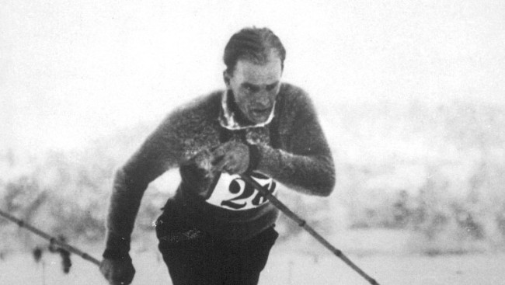
Thorleif Haug
Nordic Skiing
20km Cross-country Combined Pursuit Men
Pos | Country |  | Athletes | Result
1 |  | Norway | Thorleif Haug | 1:14:31.0
2 |  | Norway | Johan Grøttumsbråten | 1:15:51.0
3 |  | Finland | Tapani Niku | 1:16:26.0

50km Cross-country Freestyle Men
Pos | Country |  | Athletes | Result
1 |  | Norway | Thorleif Haug | 3:44:32
2 |  | Norway | Thoralf Strømstad | 3:46:23
3 |  | Norway | Johan Grøttumsbråten | 3:47:46

Nordic Combined, Individual
Pos | Country |  | Athletes | Result
1 |  | Norway | Thorleif Haug | 18.906
2 |  | Norway | Thoralf Strømstad | 18.219
3 |  | Norway | Johan Grøttumsbråten | 17.854

Ski Jump 120m
Pos | Country |  | Athletes | Result
1 |  | Norway | Jacob Thams | 18.960
2 |  | Norway | Narve Bonna | 18.689
3 |  | United States | Anders Haugen | 17.916

Speed Skating
10000m Men
Pos | Country |  | Athletes | Result
1 |  | Finland | Julius Skutnabb | 18:04.8
2 |  | Finland | Clas Thunberg | 18:07.8
3 |  | Norway | Roald Larsen | 18:12.2

1500m Men
Pos | Country |  | Athletes | Result
1 |  | Finland | Clas Thunberg | 2:20.8
2 |  | Norway | Roald Larsen | 2:22.0
3 |  | Norway | Sigurd Moen | 2:25.6

5000m Men
Pos | Country |  | Athletes | Result
1 |  | Finland | Clas Thunberg | 8:39.0
2 |  | Finland | Julius Skutnabb | 8:48.4
3 |  | Norway | Roald Larsen | 8:50.2

500m Men
Pos | Country |  | Athletes | Result
1 |  | United States | Charles Jewtraw | 44.0
2 |  | Norway | Oskar Olsen | 44.2
3 |  | Norway | Roald Larsen | 44.8
3 |  | Finland | Clas Thunberg | 44.8

Team Pursuit Men
Pos | Country |  | Athletes | Result
1 |  | Finland | Clas Thunberg | 5.5
2 |  | Norway | Roald Larsen | 9.5
3 |  | Finland | Julius Skutnabb | 11

